## **HOME Page:**

1. Arrow must be similar with actual logo.
2. Circle size should be somewhat bigger that will look better.

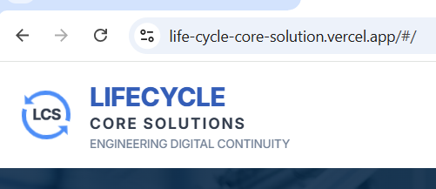

1. Reduce size of text (not much).
2. Change background image.

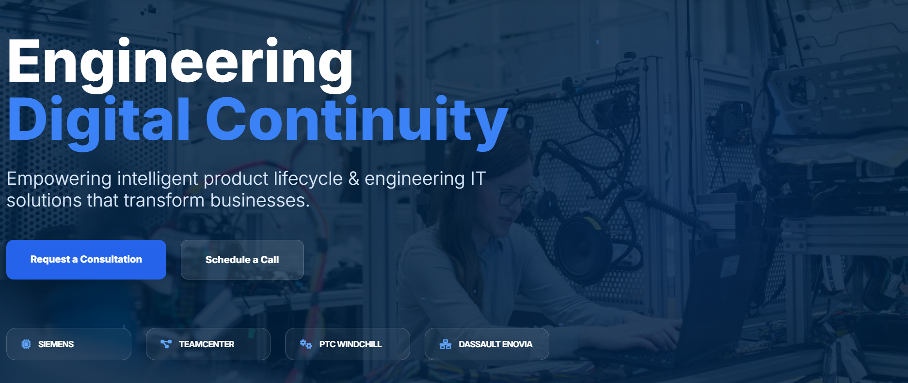

1. Remove this portion.

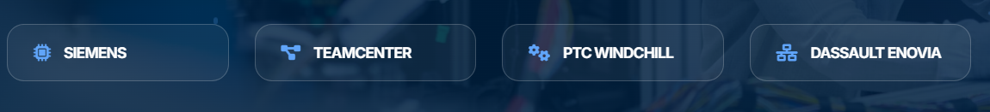

1. Add this text in place of above removed area.  
   **LCS delivers intelligent digital engineering solutions that unify product data, manufacturing operations, and enterprise systems. With expertise in PLM, PDM, MOM, MRO, Industry 4.0 (IIoT), and AI/ML technologies, we help organizations streamline workflows, enhance data visibility, and build a scalable, resilient digital enterprise.**
2. Write **Why LCS** insteadof why us

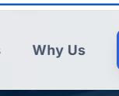

1. **Replace these with given images.  
   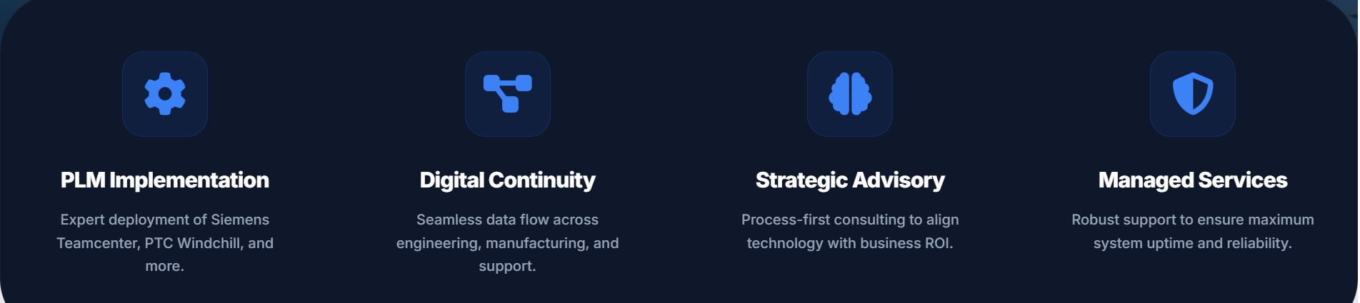**

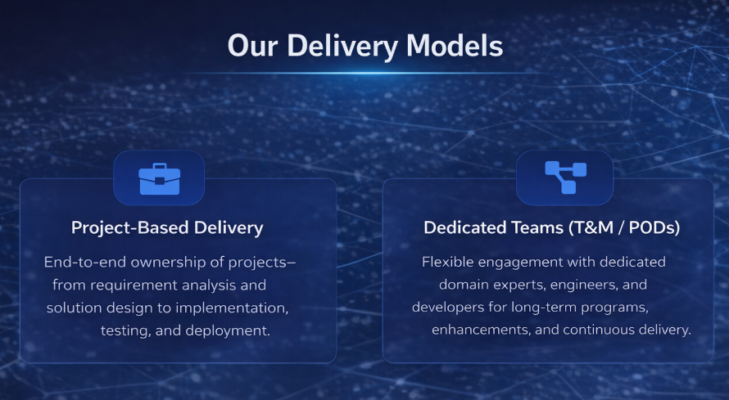

**Our industry solutions:**

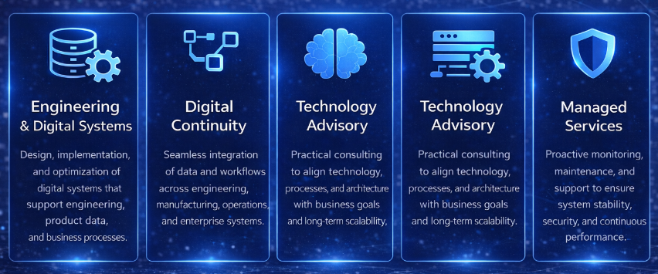

1. **View services should be remove or keep ? Keep it**



1. **Make it almost same as our logo  
   **
2. **Change text below logo  
   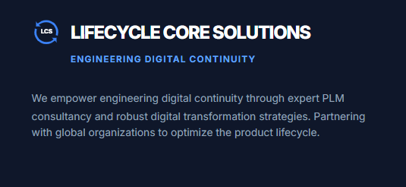**

**We empower digital continuity through expert engineering and technology solutions. Partnering with organizations to deliver scalable transformation and optimize business-critical processes across the product lifecycle.**

1. **Remove location**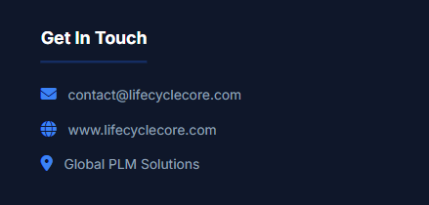
2. **Remove this line if not required.  
     
   **
3. **Disable LinkedIn and Twitter.  
     
   About Us Page**

**Add with title “our expertise”:**

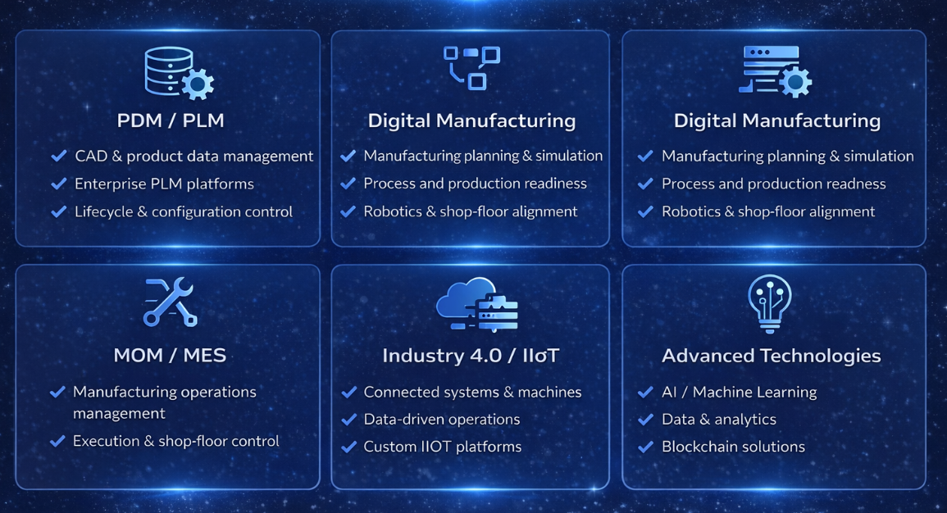

**Above Our core methodology we add companies logos (Also add on home page):**

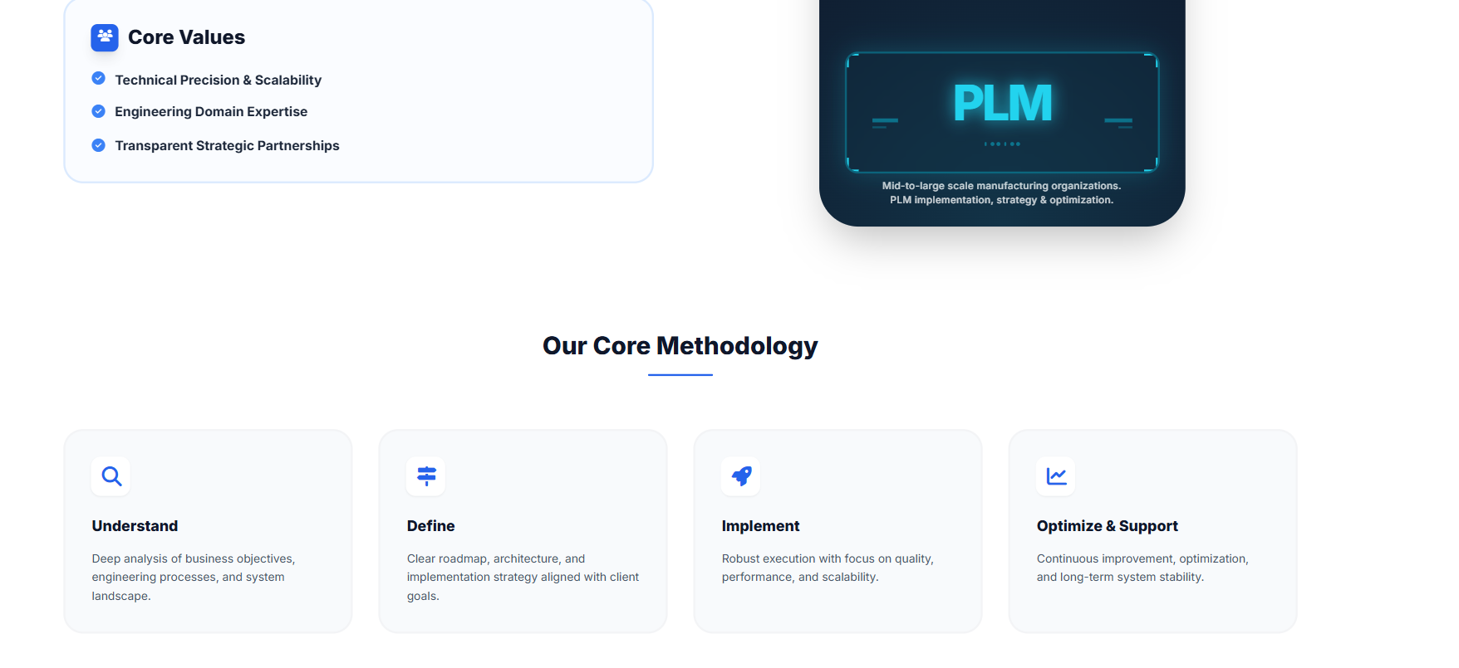

**Experience Across Leading Global Organizations:**

   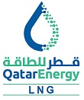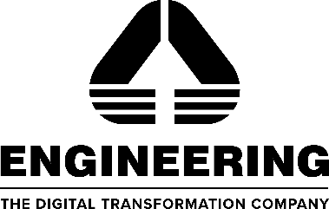

**Below this add small i icon **

Text under i icon: “Logos represent organizations where our leadership team has gained professional experience. No partnership or endorsement is implied.”

**Show the tip only when user click the icon.**

**Note: Add same on homepage as well.**

**Services**

**Add few more services:**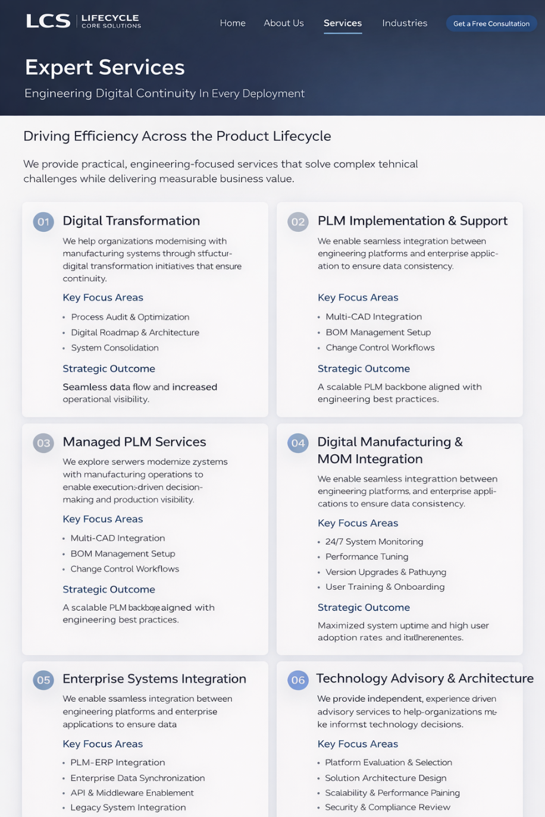

**Required: Terms and conditions and Privacy Policy. (I have to provide)**